**Exercise 2: Implementing the Factory Method Pattern**

// Product interface

interface Vehicle {

void drive();

}

// Concrete products

class Car implements Vehicle {

public void drive() {

System.out.println("Driving a car");

}

}

class Truck implements Vehicle {

public void drive() {

System.out.println("Driving a truck");

}

}

// Creator abstract class

abstract class VehicleFactory {

public abstract Vehicle createVehicle();

public Vehicle getVehicle() {

Vehicle vehicle = createVehicle();

return vehicle;

}

}

// Concrete creators

class CarFactory extends VehicleFactory {

public Vehicle createVehicle() {

return new Car();

}

}

class TruckFactory extends VehicleFactory {

public Vehicle createVehicle() {

return new Truck();

}

}

public class Main {

public static void main(String[] args) {

VehicleFactory carFactory = new CarFactory();

Vehicle car = carFactory.getVehicle();

car.drive();

VehicleFactory truckFactory = new TruckFactory();

Vehicle truck = truckFactory.getVehicle();

truck.drive();

}

}

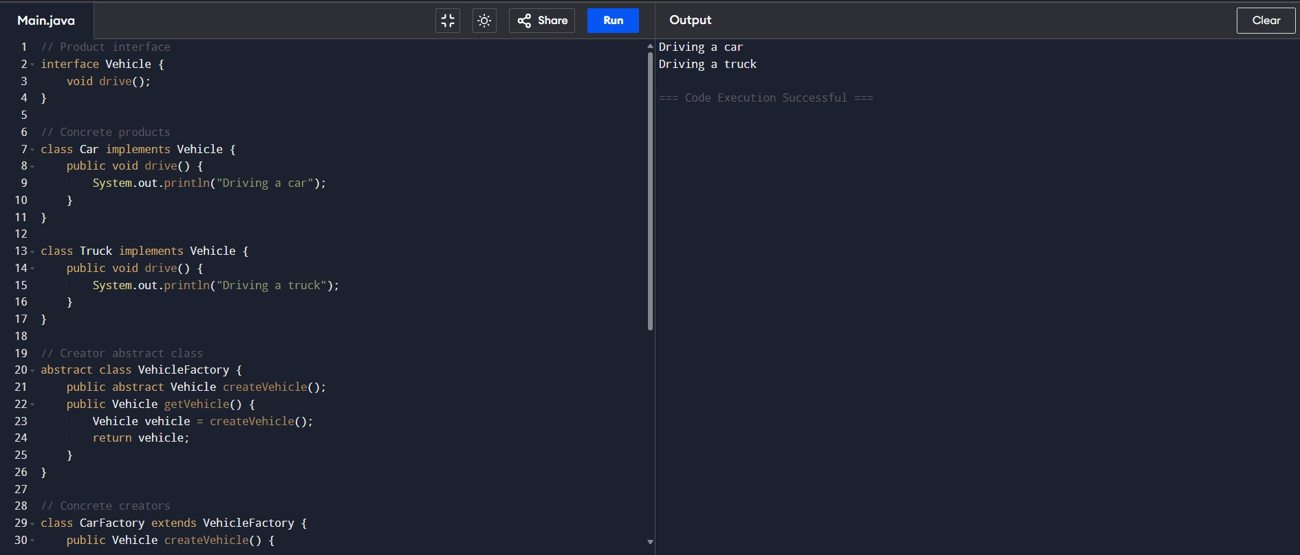Output :

Driving a car

Driving a truck